JavaScript Notes
JavaScript is a high-level, dynamic, and JIT (Just in time)-compiled programming language used to create interactive web applications.
JavaScript is a versatile programming language that runs both on the client-side (in browsers) and server-side (using Node.js).
Programming Language → Compiler/Interpreter → Machine Code → Output
Difference between Compiler and Interpreter
Compiler:
- Translates entire code at once into machine code. Faster execution after compilation.
- Output is usually a binary/executable file.
- Errors are shown after compilation.
e.g. C, C++
Interpreter:
- Translates and executes code line by line.
- No separate executable file.
- Errors appear immediately during execution.
e.g. JavaScript, Python
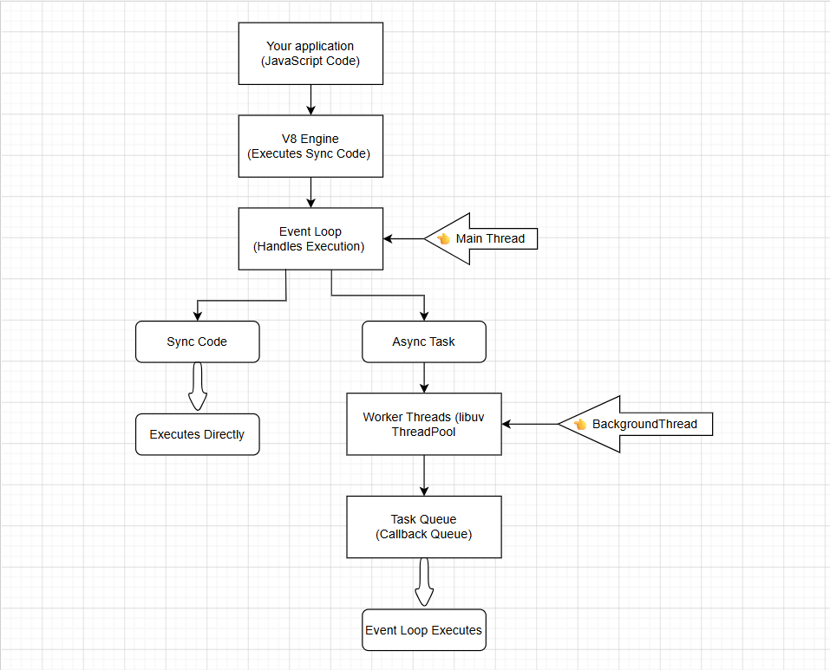
Code → Event Loop → (If heavy → Worker) → Queue → Back to Event Loop
JavaScript code runs on the V8 engine. The event loop handles execution in a single thread. If a task is synchronous, it executes immediately. If it is asynchronous, it is delegated to worker threads using libuv. Once completed, the result is placed in the task queue, and the event loop processes it when the call stack is free.
Do I handle it or delegate it?
- Handle → Sync → Event Loop
- Delegate → Async → Worker → Queue → Back
Browser features:
The console object is a browser/runtime-provided debugging tool (not part of core JavaScript). It is also available in environments like Node.js.
There are some types of consoles are:
- console.log("Message");
- console. warn ("Warning");
- console. error ("Error");
- console.info("Info");
- console. table ([{name: "Varun"}]);
Where it is used?
- Debugging applications
- Logging API responses
- Inspecting objects and arrays
- Monitoring app behaviour during development
Limitations / Notes
- Not meant for production logging (use logging frameworks instead)
- Too many logs can impact performance.
- Can expose sensitive data if left in production.
Alert:
Displays a popup message box with an OK button.
alert ("Are you sure?");
Where it is used
- Simple notifications (mainly learning/demo)
- Quick debugging in early stages
Limitations / Notes
- Blocking → stops all JavaScript execution
- Poor user experience
- Not used in modern applications (replaced by custom UI modals)
Prompt:
Displays a popup to take user input.
prompt ("Who are you?")
let name = prompt ("Enter your name");
Where it is used
- Basic input collection (learning/demo)
- Small scripts or prototypes
Limitations / Notes
- Returns:
- String (input)
- null (cancel)
- Blocking
- Not suitable for real applications (no validation/UI control)
Confirm:
Displays a popup with OK / Cancel options.
confirm ("Do you want to continue?");
let result = confirm ("Do you want to continue?");
Where it is used
- Simple confirmation actions (demo/basic apps)
Limitations / Notes
- Returns:
- true → OK
- false → Cancel
- Blocking
- Rarely used in production apps.
Browser features are APIs provided by the browser environment, not part of core JavaScript. JavaScript can interact with these features using global objects like window.
Variables:
Memory: Stack and Heap
Feature | Stack | Heap
Stores | Primitive values | Objects, arrays, functions
Access | Direct value | Reference (address)
Speed | Fast | Slower than stack
Size | Fixed / limited | Dynamic / large
Memory | Automatically managed | Managed by Garbage Collector
Example | let a = 10 | let obj = {}
Stack stores primitive values directly, while heap stores objects and variables hold references to those objects.
What are Primitive Values?
Primitive = simple, single value (not a collection)
All Primitive Types in JavaScript
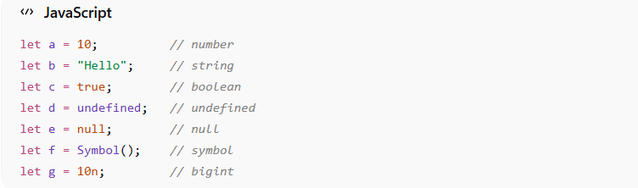
Key Characteristics:
- Stored directly in memory (stack)
- Immutable (cannot be changed)
- Copied by value.
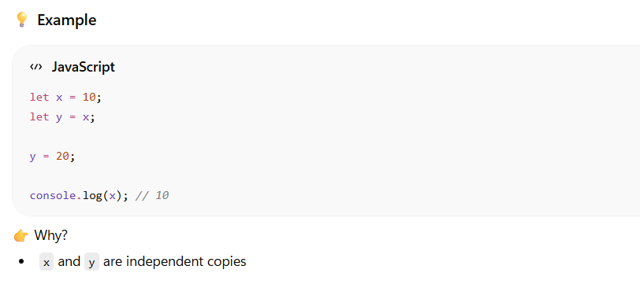
What are Objects (Reference Types)?
Object = collection of data (key-value pairs)
Example of Objects:
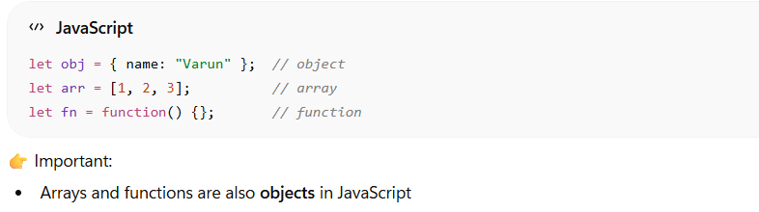
Key Characteristics:
- Stored in heap
- Variables store reference (address)
- Copied by reference.
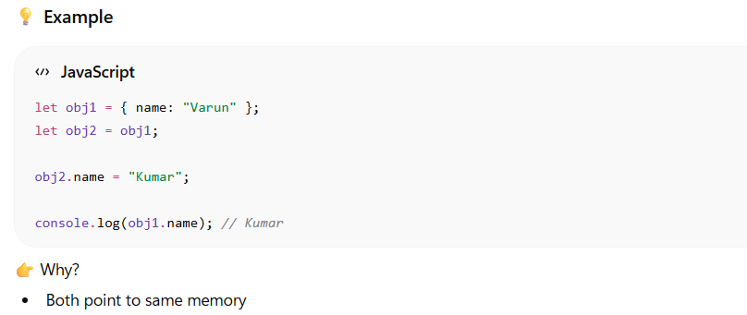
Feature | Primitive | Object
Type | Single value | Collection
Stored in | Stack | Heap
Copy | By value | By reference
Mutable | No | Yes
- Primitive values (number, string, boolean, null, undefined, symbol, bigint) are stored directly and copied by value.
- Objects (arrays, functions, object literals) are stored in memory separately, and variables hold references (addresses) to them.
- When assigning objects, only the reference is copied, so changes affect all variables pointing to that object.
var vs let vs const:
- var is function-scoped and can lead to unexpected behaviour due to redeclaration and lack of block scope.
var → function scope (danger)

- let is block-scoped and allows reassignment but not redeclaration.
let → block scope (safe)

- const prevents reassignment, but allows mutation of objects.
const → block scope + no reassignment.
JavaScript provides three ways to declare variables: var, let, and const. var is function-scoped and allows redeclaration, which can cause issues. let and const are block-scoped and preferred in modern JavaScript. let allows reassignment, while const does not, although object properties can still be modified.

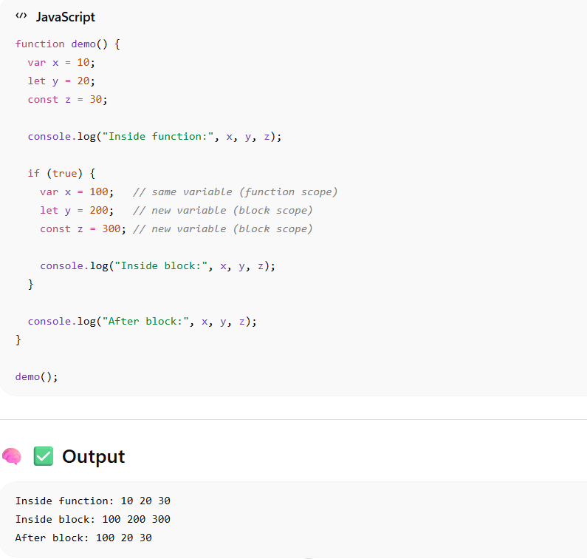
Data types in JavaScript:
- JavaScript data types are divided into primitive and non-primitive types.
- Primitive data types include:
string, number, boolean, undefined, null, symbol, and bigint.
- Non-primitive or reference data types include:
objects, arrays, and functions.
- undefined represents a variable that is declared but not assigned a value.
- null represents an intentional absence of value.
- "not defined" is not a data type, it is a runtime error when a variable is not declared.

- Primitive → single value
- Object → reference
- undefined → not assigned
- null → intentionally empty
- not defined → error
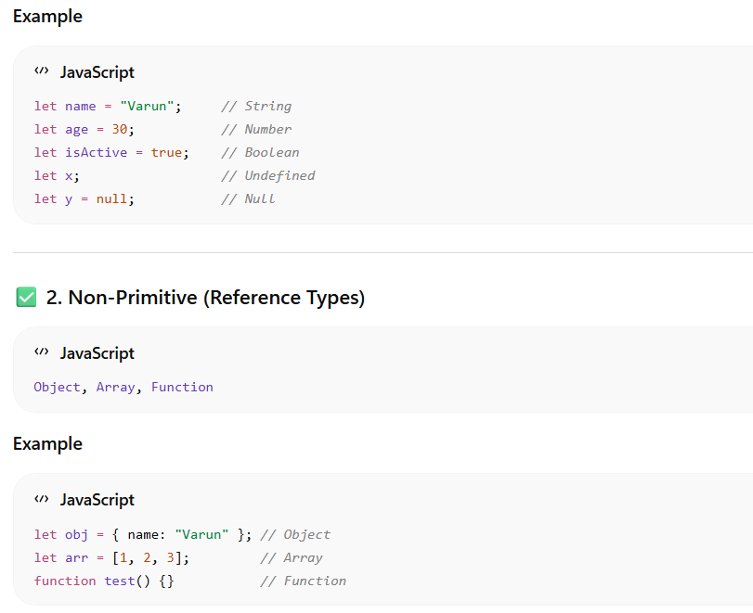
  - Arrays and objects:
What is an array in JavaScript?
An array in JavaScript is used to store multiple values in a single variable. Each element is stored with an index starting from 0. Arrays are mainly used for handling lists such as users, products, employees, or cart items in real-time applications.
Why do we use arrays?
Arrays help organize and manage multiple related values efficiently instead of creating many separate variables.
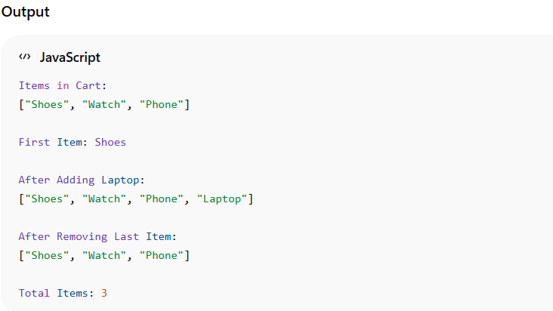
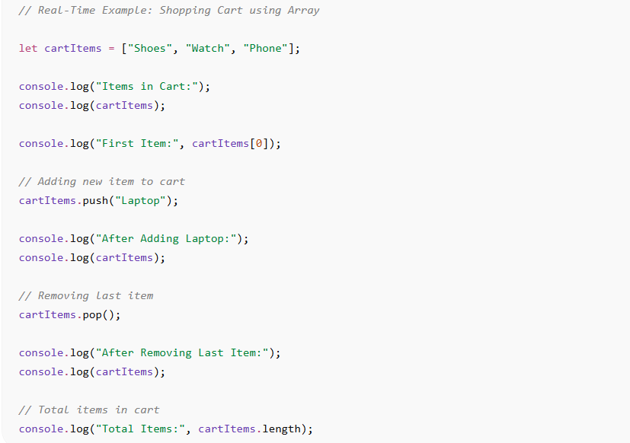

In this example, I used an array to store shopping cart items. I accessed array elements using indexes, added new items using push () it always added the values at the end, removed items using pop () it always removed the values at the end, and counted total items using length. This is a real-time use case similar to e-commerce applications.
arr. splice (indexValue, deleteCount) If we want to delete the index values in between of array we can use this function.
arr. splice (indexValue, deleteCount, addValues) If we want to add the values to the array we can use this function.
Why the arrays show object as the datatype in JavaScript?
Arrays in JavaScript get converted into an object then it is stored, that is the reason when it searches the datatype of array it shows an object. But this is not a good practice and we are not using it in the future.
What is object in JavaScript?
An object in JavaScript is a collection of key-value pairs used to store related data about a particular entity.
Objects are mainly used when we need to represent real-world data with multiple properties, such as employee details, product information, or user profiles.
For example, an employee object can contain name, age, department, and salary together inside a single variable.
We can access object values using keys with dot notation or bracket notation.
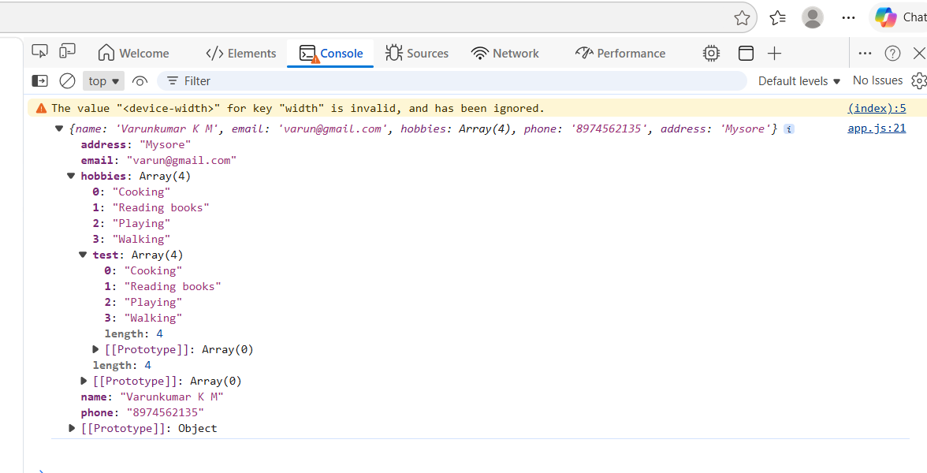
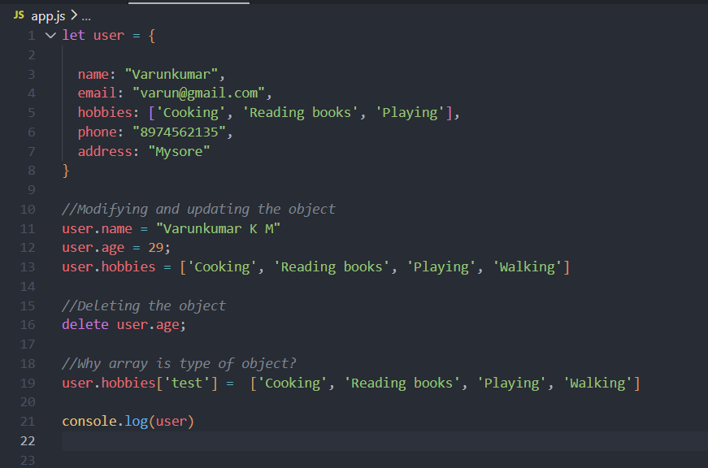
Array of objects
An array of objects in JavaScript is a combination of both arrays and objects.
It is used to store multiple objects inside a single array. Each object represents one record with its own properties.
This is mainly used in real-time applications for handling collections of structured data such as users, employees, products, orders, or student records.
The array helps store multiple records, and the object helps store detailed information about each record
Array - Stores multiple records, Object - Stores details of one record, Array of Objects - Stores multiple detailed records.
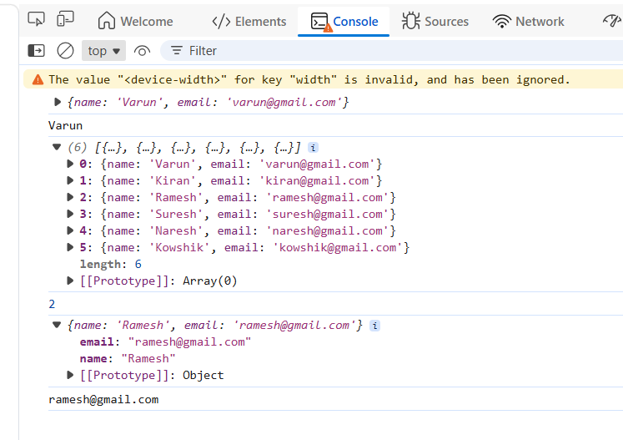
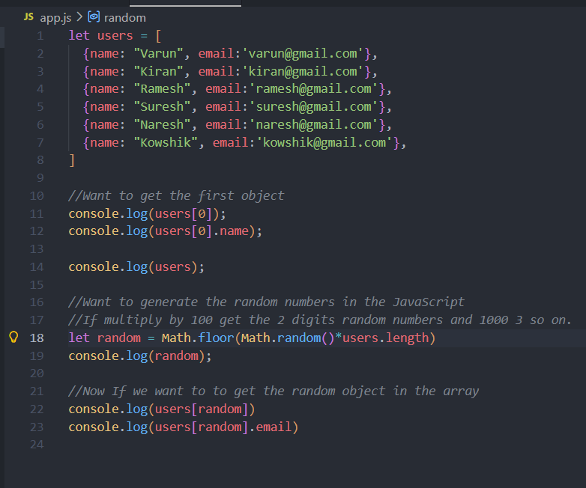
  - Conditionals:
Conditional statements in JavaScript are used to make decisions in a program based on conditions. Common conditionals are if, if-else, else-if, switch, and ternary operator. They are widely used in real-time applications like login validation, payment systems, and role-based access control.
- Comparison Operators
Operator | Meaning | Example | Output
== | Equal (checks value only) | 5 == "5" | true
=== | Strict Equal (value + datatype) | 5 === "5" | false
!= | Not Equal | 5! = 10 | true
!== | Strict Not Equal | 5! == "5" | true
> | Greater Than | 10 > 5 | true
< | Less Than | 5 < 10 | true
>= | Greater Than or Equal | 10 >= 10 | true
<= | Less Than or Equal | 5 <= 10 | true
- Logical Operators
Operator | Meaning | Example
&& | AND | age > 18 && citizen === true
` |  | `
! | NOT | ! isLoggedIn
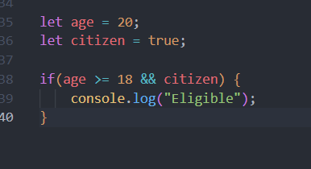
- Arithmetic Operators

- Arithmetic Operators
Operator | Meaning | Example
+ | Addition | 5 + 2
- | Subtraction | 5 - 2
* | Multiplication | 5 * 2
/ | Division | 10 / 2
% | Modulus (remainder) | 10 % 3
++ | Increment | count++
-- | Decrement | count--
- Assignment Operators
Operator | Example | Same As
= | x = 5 | Assign value
+= | x += 2 | x = x + 2
-= | x -= 2 | x = x - 2
*= | x *= 2 | x = x * 2
/= | x /= 2 | x = x / 2
- Ternary Operator
Short form of if-else.
Syntax is - condition? trueValue: falseValue
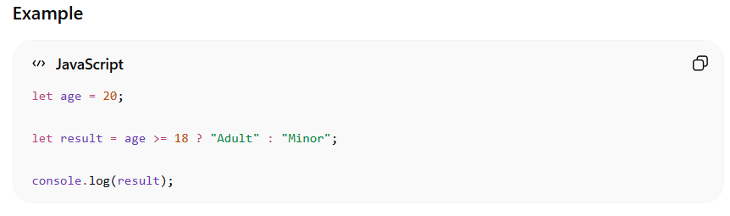
- == (equals to) compares only values, whereas === (Strictly equals to) compares both value and datatype. In real-time applications, === is preferred because it avoids automatic type conversion issues.
- and operator (&&) => When both the conditions are true then result is true else false.
- or operator (||) => When any one condition is true then the final result is true. When both the conditions are wrong then the result is false.
- Ternary Operator => false? console.log(‘Hello!’): console.log (‘Bye!’)
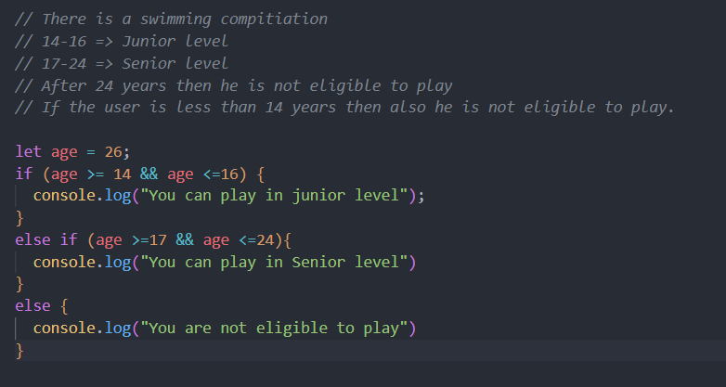
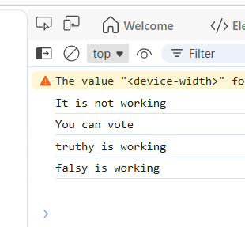
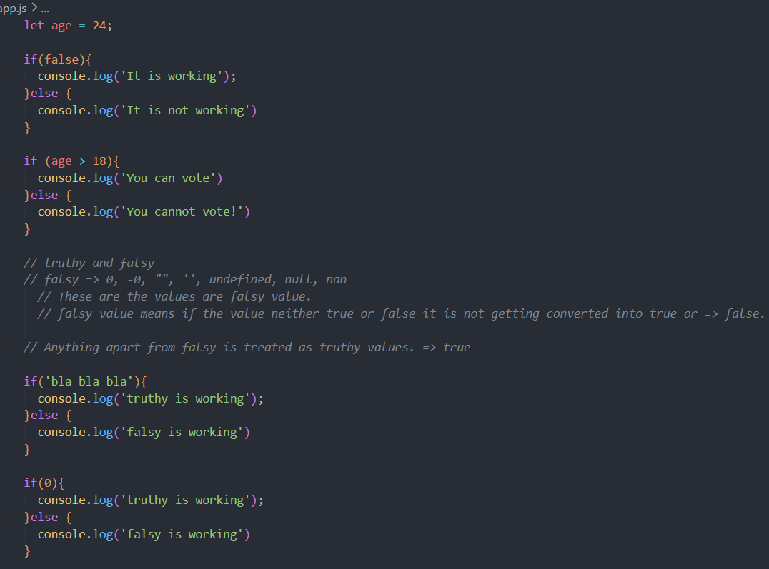
Output:
You are not eligible to play

3) Functions:
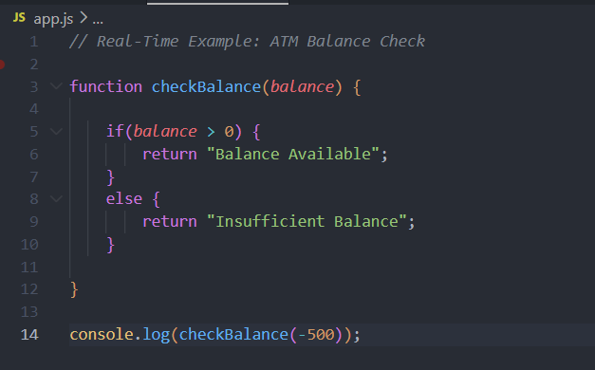
Functions in JavaScript are reusable blocks of code used to perform specific tasks. They help avoid code repetition and improve code organization. Functions can accept parameters, return values, and are widely used in real-time applications like authentication, calculations, and form handling.
Output is:
Insufficient Balance

Function = Machine
You give input → it processes → gives output.

- Arrow Function:
Arrow functions are a shorter and modern way of writing functions in JavaScript. They were introduced in ES6 (ECMAScript 2015).
They simplify function syntax and inherit this from the surrounding scope, making them useful for callbacks and modern frontend development.
Difference Between Normal Function and Arrow Function
Normal Function | Arrow Function
Uses function keyword | Uses =>
Has its own this | Does not have its own this
More traditional | Modern concise syntax
Can be hoisted | Usually not hoisted when stored in variable
this refers to calling object | this comes from parent scope
Best for object methods | Best for callbacks and short functions
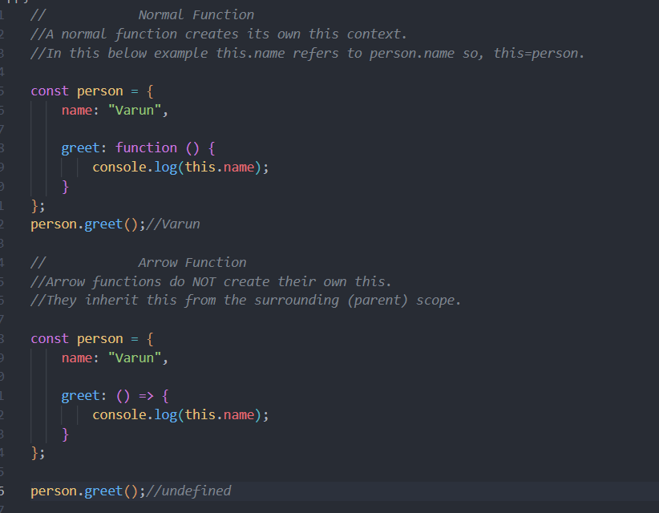
Why Output is undefined for arrow function?
In arrow functions: this
does not refer to the person object.
Instead, it takes this from the outer/global scope.
Since the global scope usually does not contain: name
the output becomes: undefined

When to Use Arrow Functions?
Arrow functions are mainly used for:
- Callback functions
- Array methods (map, filter, forEach)
- Short reusable functions
- React functional components
When NOT to Use Arrow Functions?
Avoid arrow functions for:
- Object methods
- Constructor functions
- Functions requiring dynamic this
Why arrow function returns undefined in object methods?
Because arrow functions do not bind their own this. They inherit this from the outer scope instead of the object calling the method.
Arrow Function Parameters:
- When there are no parameters, use empty parentheses.
const functionName = () => {};

- One Parameter
const functionName = parameter => {};

- Multiple Parameters
const functionName = (param1, param2) => {};

- Return Statement
const multiply = (x, y) => {
return x * y;
};
console.log (multiply (5, 4));

- Short Arrow Function (Implicit Return)
If there is only one line, return and {} can be skipped.
const square = num => num * num;
console.log (square (5));

- Default Parameters
const greet = (name = "Guest") => {
console.log ("Hello " + name);
};
greet ();

- Rest Parameters
Used to accept multiple values.
const numbers = (...nums) => {
console.log(nums);
};
numbers (10, 20, 30, 40);
Arrow functions support different types of parameters such as no parameters, single parameters, multiple parameters, default parameters, and rest parameters. They provide concise syntax and are widely used in modern JavaScript development.

Loops in JavaScript
Loops in JavaScript are used to repeatedly execute a block of code until a condition becomes false. Common loops are for, while, do...while, for...of, and for...in. Loops are widely used for iterating arrays, objects, and processing dynamic data in real-time applications.
Which loop is mostly used?
The for loop is most commonly used because it provides initialization, condition checking, and increment/decrement in a single line.
Types of Loops in JavaScript:
Loop | Purpose
for loop | Run code fixed number of times
while loop | Run while condition is true
do...while loop | Executes at least once
for...of | Loop through array values
for...in | Loop through object keys
forEach () | Array iteration method

- for loop - Most commonly used loop. Syntax – for (initialization; condition; increment/decrement) {}
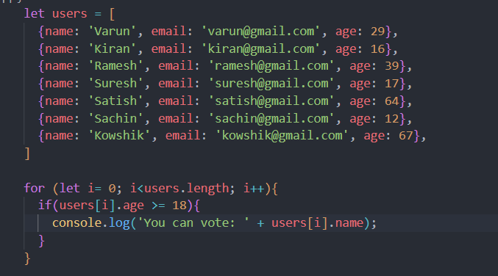
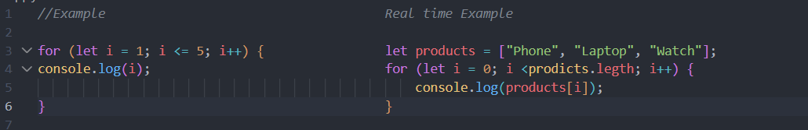

Output:
You can vote: Varun
You can vote: Ramesh
You can vote: Satish
You can vote: Kowshik

- foreach loop - Modern array iteration method. It Only works with array.
forEach () is an array method used to iterate through array elements. It executes a callback function once for each element and is widely used in modern JavaScript and React applications because of its clean and readable syntax
Syntax array. forEach ((value, index) => {});
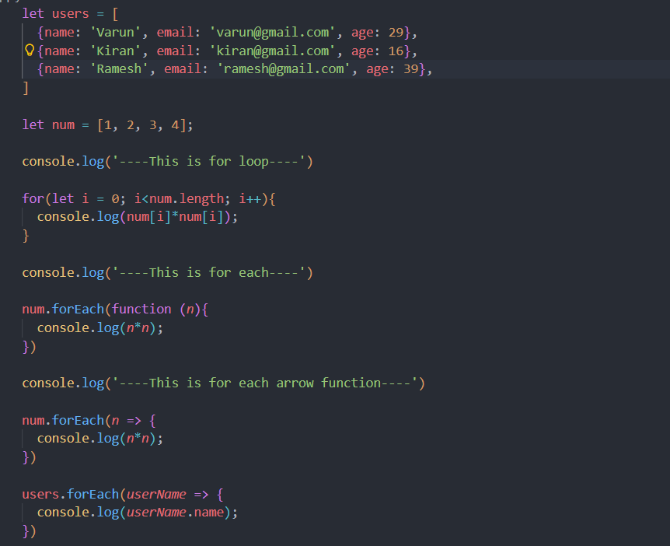
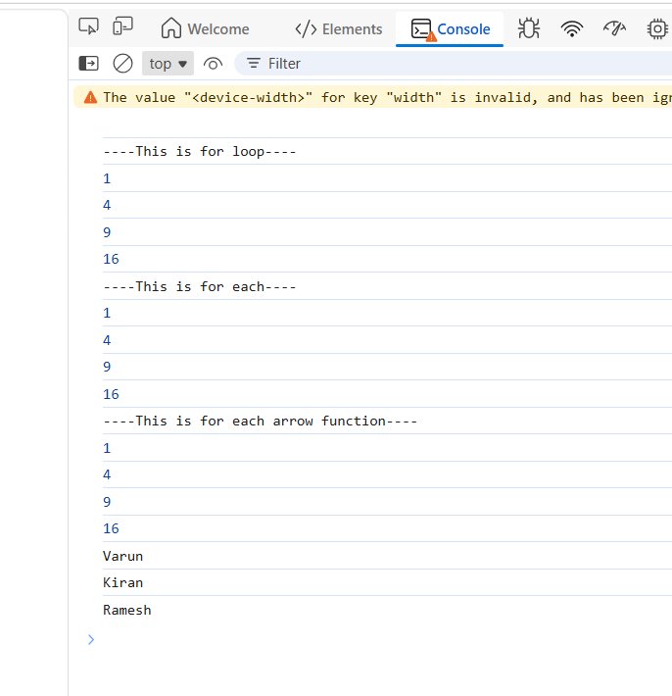

Array Mapping & Filters:
map () and filter () are higher-order array methods in JavaScript. map () is used to transform array elements and return a new array, while filter () returns only elements that satisfy a condition. They are widely used in React and modern JavaScript applications for handling dynamic data.
- map () -> Modify/Transform
- filter () -> Select/Filter
Difference Between map () and filter ()
map () | filter ()
Transforms data | Filters data
Returns same array length | Length may change
Modifies every element | Returns matching elements only
Used for formatting | Used for searching/filtering
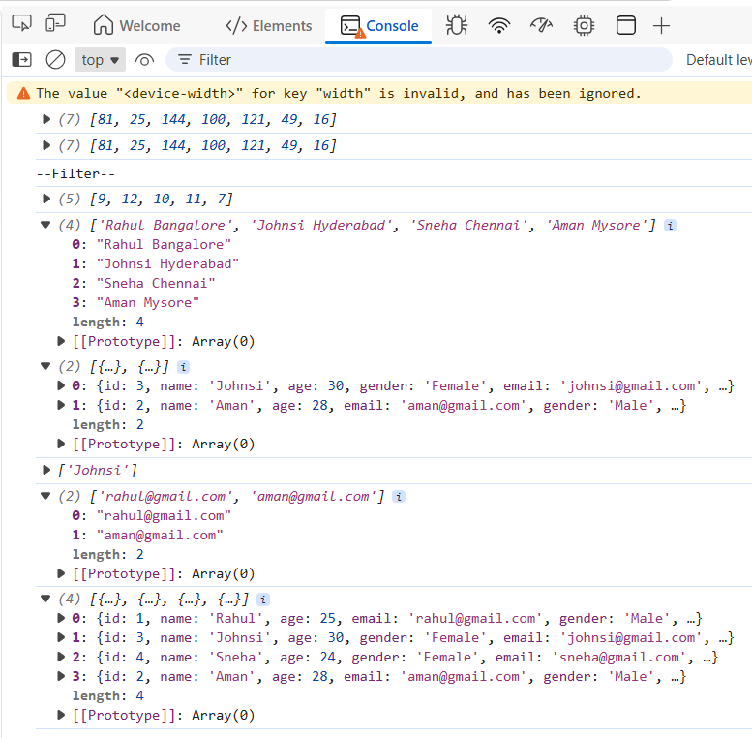
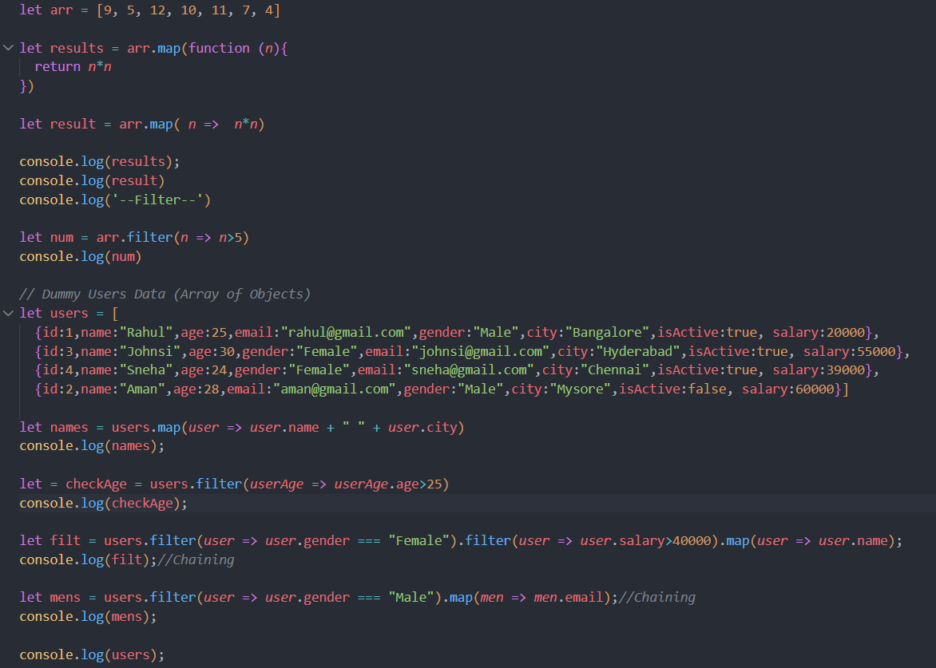

Difference Between forEach () and map () in JavaScript
forEach () is used for iterating through array elements and performing actions, whereas map () is used to transform array elements and return a new array. map () is commonly used in React and modern JavaScript applications for rendering and data transformation.
forEach () | map ()
Used for iteration | Used for transformation
Does not return useful array | Returns new array
Mostly used for side effects | Used for modifying data
Cannot chain effectively | Can chain methods
Includes () - Used to check whether a value exists inside an array.

